SOP: SOP Library
Module | SOP Library
Who uses it | Admin, Super Admin, Project Manager (manage); everyone else (view)
Version | 1.0
Issued | 21 Oct 2026
Screenshots are taken from the HRMS test copy. Names, dates and numbers are examples only.

1. Purpose
The SOP library holds the organisation's procedures, grouped by topic. Each item is a link (for example a shared-drive file) or an uploaded document.

2. Manage the library
Admin, Super Admin and Project Manager open it from Manage > SOPs (it is not in their top menu).
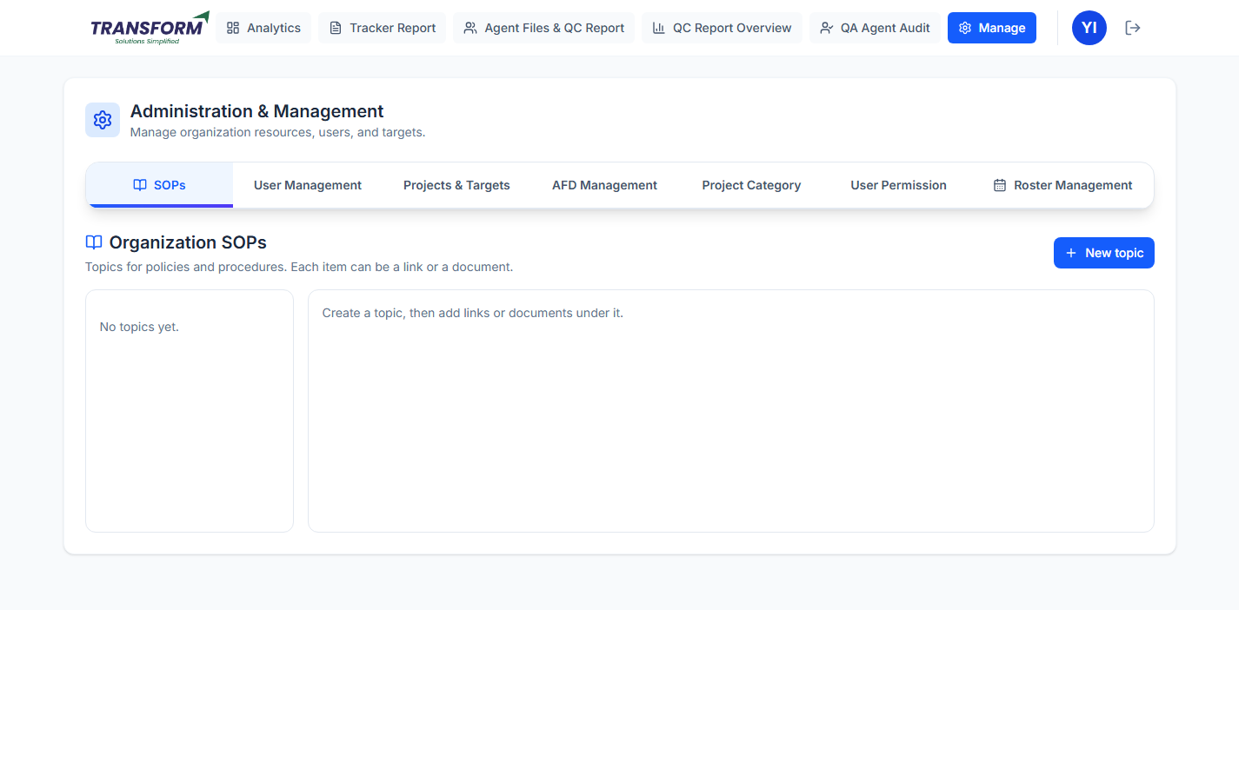
Figure 1: SOP library
1. Click New topic, enter the topic (for example Attendance, Leave, Quality) and an optional description, then save.
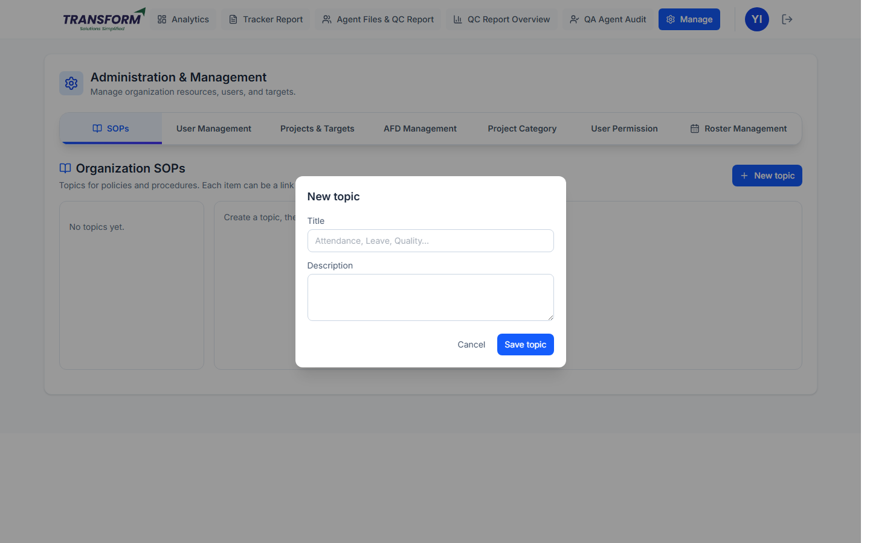
Figure 2: New topic
2. Open the topic and use Add to <topic>: give the item a title, then either paste a link (must start with https://) or upload a document, and save.
3. Remove an item or a whole topic with the bin (removing a topic removes everything in it).

3. View the library
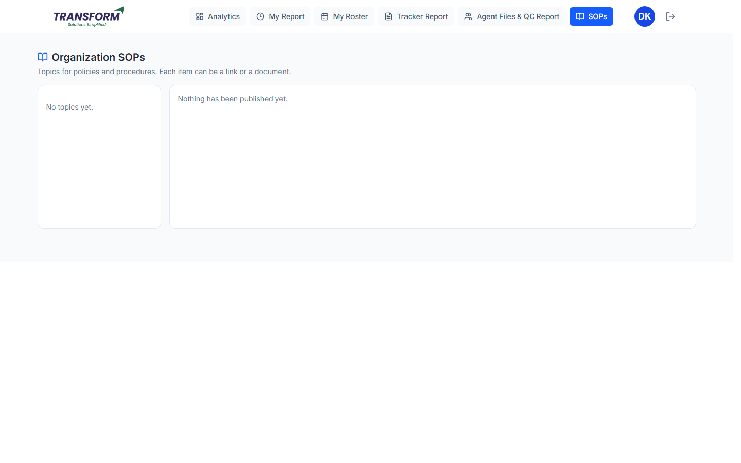
Figure 3: SOP library - view
Agents, QA, Assistant Team Leaders and Assistant Managers open SOPs from the top menu (view only). Links open in a new tab; documents download.

4. Tips
- Upload these Word SOPs here, one topic per role (Agent, QA, Manager, Admin).
- For shared-drive links, share the file as Viewer first.

